**Lab 02a - Manage Subscriptions and RBAC**

***Mihail Elencevski***

#### Task 1: Implement Management Groups

*I am setting up and configuring management groups in Azure to organize and manage resources across different subscriptions in your Azure environment.*

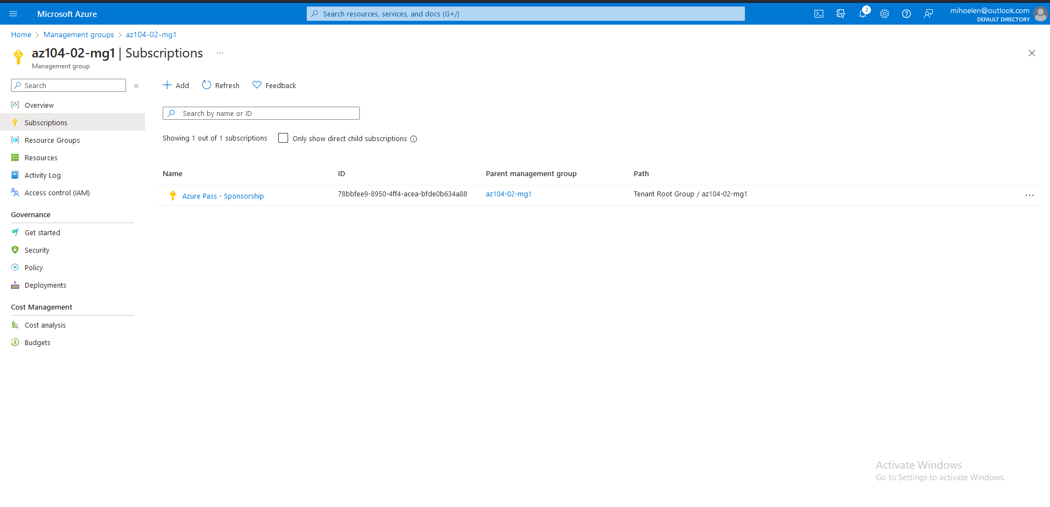

#### Task 2: Create custom RBAC roles

*I am defining a custom role-based access control (RBAC) role to specify permissions for Azure resources.*

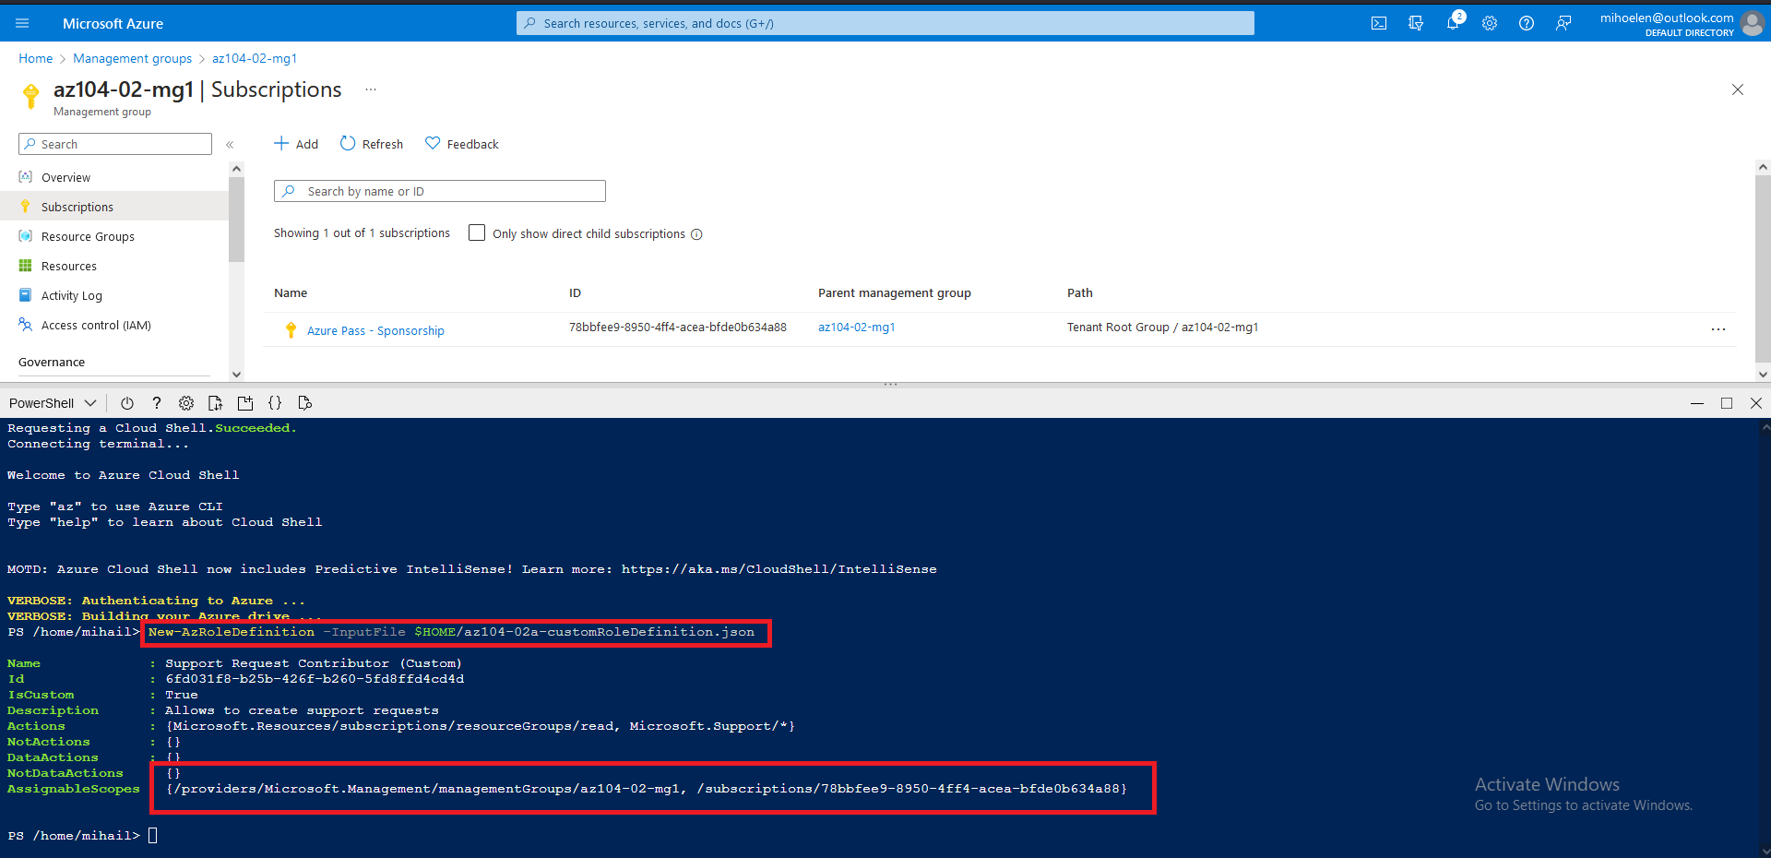

#### Task 3: Assign RBAC roles

*In this task, I created an Azure user, granted them a specific role, and verified their ability to perform authorized tasks.*

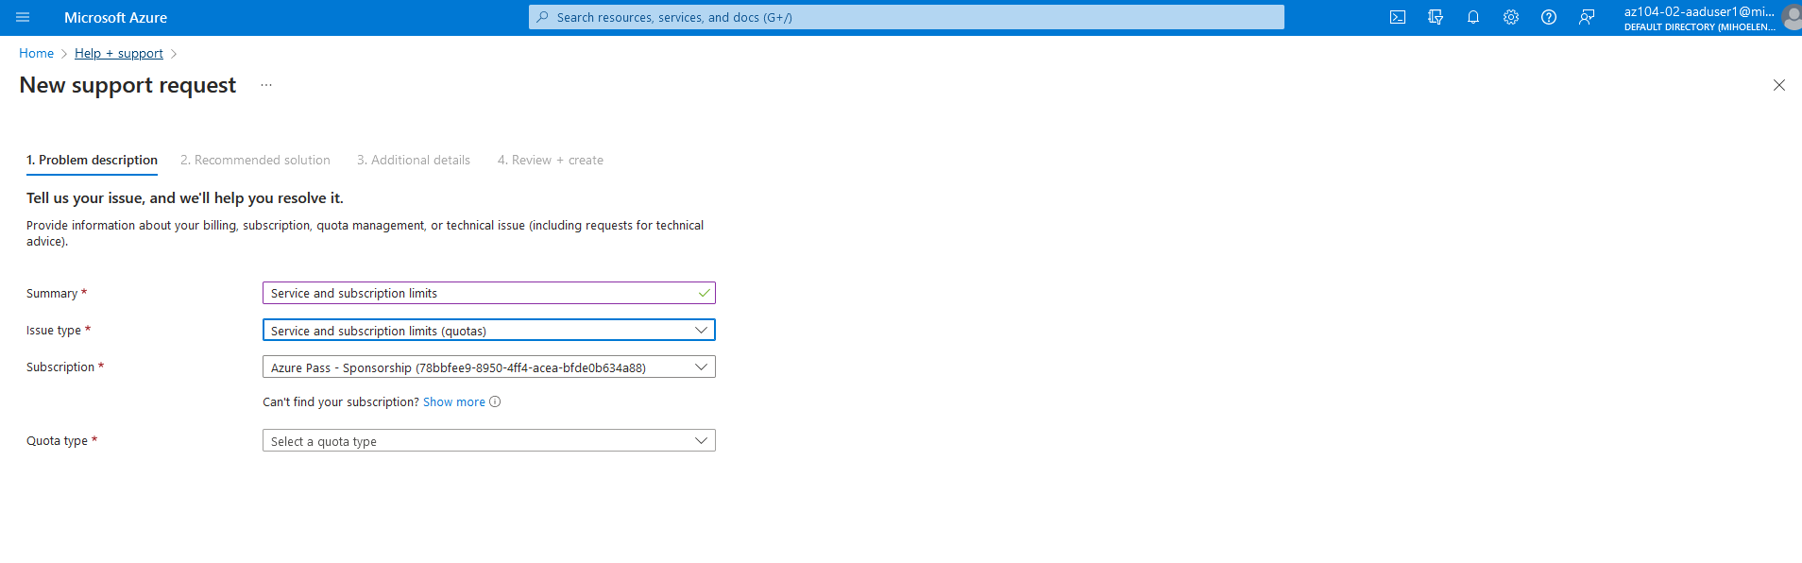

#### Task 4: Clean up resources

*Here I am removing the assignment of the custom role definition.*

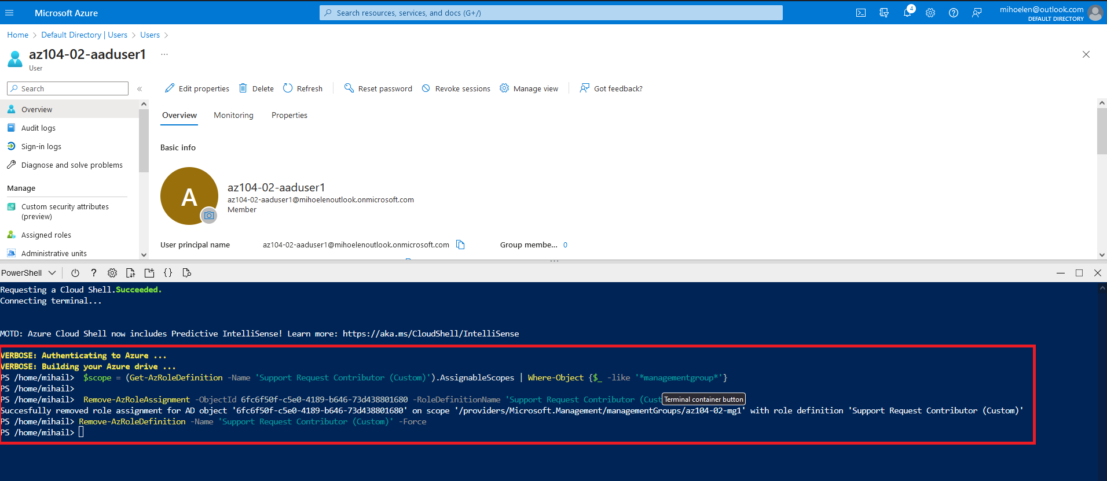

*Here I am displaying that I removed the user.*

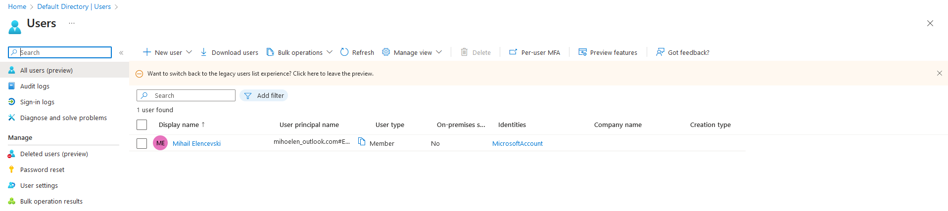

*In this scenario I am displaying that I moved the subscription of the* ***az104-02-mg1*** *management group to the* ***Tenant Root management group****. Also the last step which was to delete the* ***z104-02-mg1*** *management group.*

